Analysis of Used Car Sale Prices in Canada

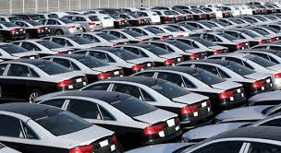

Data 603:Statistical Modelling With Data

University of Calgary

Fall 2020

Group 2: Karl Norrena , Peter Checknita, Raghu Bhaskar

Table of Contents

Introduction 4

Data Sources 4

Data Loading and Preliminary Cleaning 4

List of, Definition, and Exploration of Variables 5

Year (Continuous Independent Variable) 5

Body Type (Categorical Independent Variable) 5

Make (Categorical Independent Variable) 6

Model (Categorical Independent Variable) 6

Kilometres (Continuous Independent Variable) 6

Wheel config (Categorical Independent Variable) 7

Transmission (Categorical Independent Variable) 7

Fuel (Categorical Independent variable) 8

City (Categorical independent Variable) 8

Price (Continuous Dependent Variable ) 8

Linear Modelling Strategy 10

Known, but unavoidable linearities 10

Sensical Models versus Nonsensical Models 11

First Order Model and Initial Coefficient Selection 12

Identifying Significant Predictors for Model 12

Model 1: 12

Model 2: 13

Model 3: 13

Model 4: 14

Final First Order Model: 14

Checking For Outliers 15

T Tests for individual Coefficients 16

Checking for the Interaction Terms in our model 16

Checking for Higher Order Terms (Higher Order Terms): 17

Multiple Regression Assumptions 19

Linearity Assumption 19

Independence Assumption 19

Normality Assumption 19

Homoscedasticity Assumption 20

Conclusion 21

The Effects of each individual independent variable: 22

MLR 22

Further Discussion 23

Predictions of prices based on our model: 23

Possible Improvements: 23

References 23

Appendix 25

Introduction

Unfortunately owning a vehicle in Canada isn’t a luxury, it’s a necessity. Temperature extremes and weather conditions make getting around in the winter very challenging, if not deadly. Aside from the larger centres like Toronto, Montreal, Ottawa, Vancouver, the population density is low and sparse enough that not all cities are as accessible. Covid19 is making public transport risky as well.

Last year the auto industry contributed $19B to Canada’s GDP, and it is one of Canada’s largest manufacturing sectors. The industry directly employs more than 125,000 people, with an additional 400,000 people in aftermarket services and dealership networks.

There are many options when it comes to car ownership: new, used, re-stored, re-newed, pickup truck, SUV, sports car, or supercar. This project explores these options through Kijiji. According to Kikiji, “Kijiji is a platform that allows Canadians to exchange goods and services, find work, and build their businesses locally.” Kijiji facilitates this project by connecting sellers and buyers. The seller posts an ad with (sometimes) relevant data, the buyer assess the data and a transaction can occur. The data entered by the seller drives this project.

To post a car for sale on Kijiji the seller is mentored through the data entry process and prompted for province, city, the VIN number for the car, plus other details. The data advantage here is that the data is semi structured (we suspect the data is housed in either a nosql, or mongodb database), consistent, and constrained. The seller can’t misspell the manufacturer, or confuse models because the data is populated through drop down menus. The only free data entry points are price and kilometres, and the opportunity to select “other”. These data cause issues. Some sellers price their cars into the millions, and others will price the car with a negative value in an attempt to exploit the ranking procedure and bring added attentions to the car. In some cases the seller fails to populate data and Kijiji defaults to “other”. For example, if the seller does not select a color, kijiji defaults to “other” as a color.

The project aims to prepare a regression model the predicts price using as many kijiji predictors as necessary and possible. Some of the predictors impart collinearities. For example, many manufactures manufacture the same car under multiple manufacturer names. General Motors Corporation and Chevrolet both produce pickup trucks with the same model name and the distribution of prices are strongly correlated.

# Data Sources

The project data was sourced from Kijiji postings in the following cities: Calgary, Edmonton, Toronto, Vancouver, Winnipeg, Fredericton, Halifax, Regina, Whitehorse, and Charlottetown. The data is not curated and is a sample of the most recent listings on the day it was collected.

# Data Loading and Preliminary Cleaning

The data values for the project were fairly clean. Numerical data was clearly numerical, and categorical (string) data, like colors, came as strings. Some effort had to be spent on manual cleaning of data. For example, Some cars had prices of -999 or 999,999.00. These we removed manually.

# List of, Definition, and Exploration of Variables

## Year (Continuous Independent Variable)

This integer refers to the year of manufacture. The data spans 1928 to 2021, almost 100 years. This is continuous data.

The mean model year over all the data is 2014.14, implying the average age of a car posted on Kijiji is 6 years. The distribution of Years is strongly left skewed, as it should be; there are no 2022 cars on the road yet. The observed skewness is due to cars reaching the end of their service life and some collectible cars being restored.

Entries where the Year was listed as “other” were deleted. Defining outliers outside the set of 1928 to 2021 is ineffective because Year is not a measured variable thus no outliers exist.

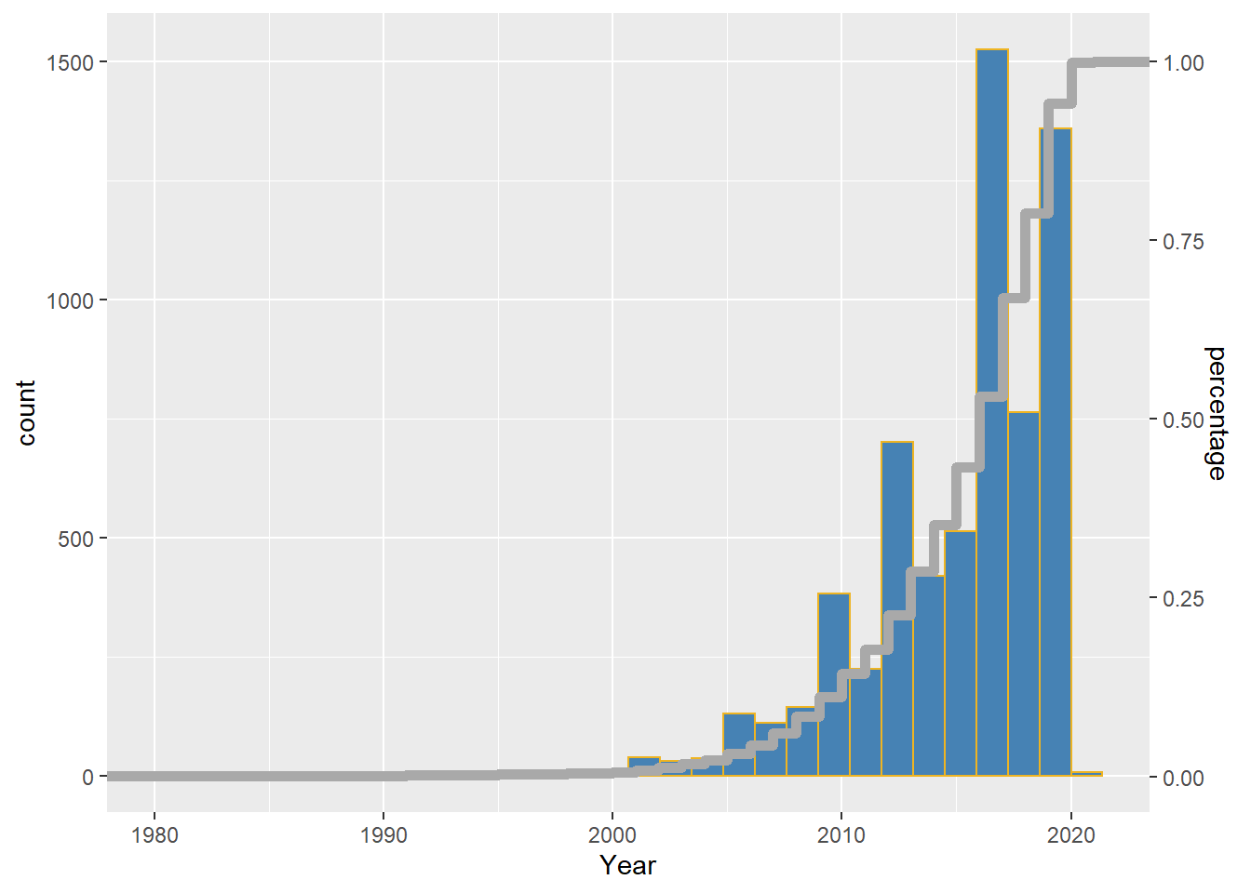

## Body Type (Categorical Independent Variable)

Vehicles can be broadly classified by body type. The data contains the following body type classifications: Minivan_Van, SUV_Crossover, Sedan, Hatchback, Wagon, Pickup, Coupe, Other, Convertible. If a body type is listed as other, it was deleted from the dataset.

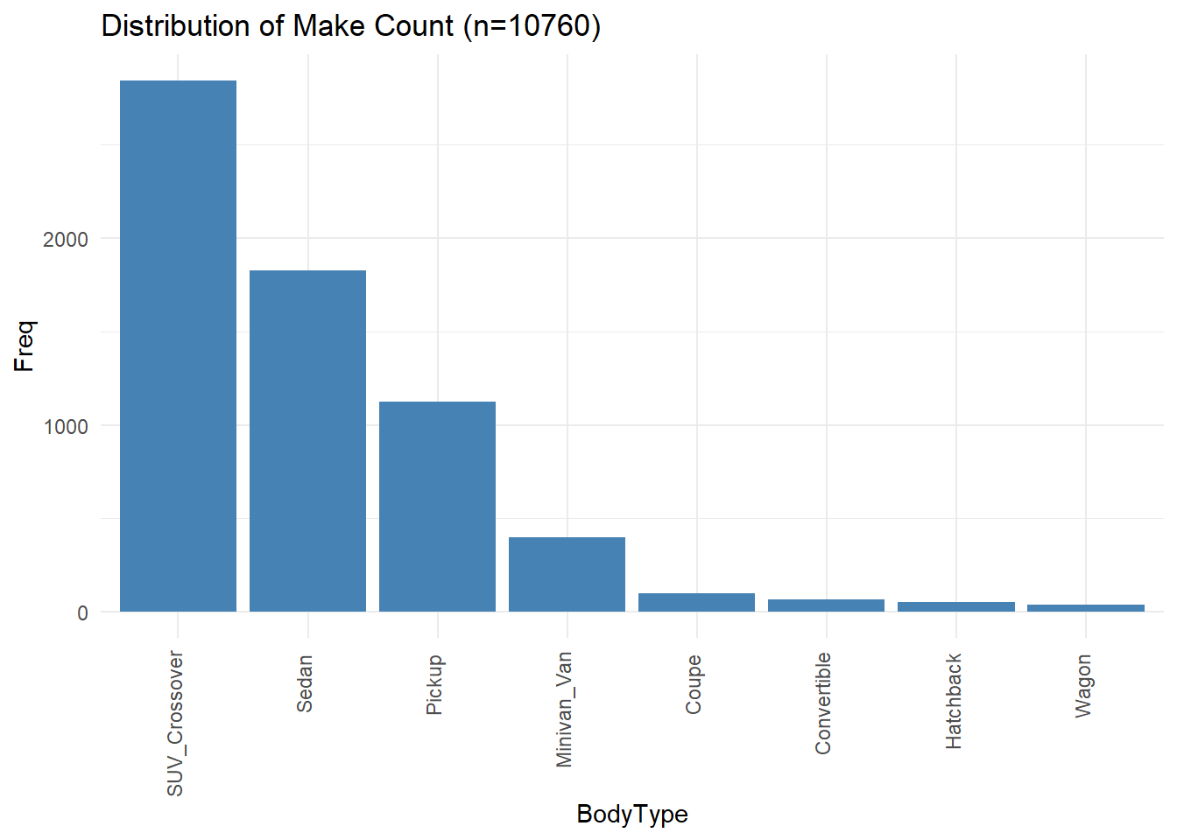

## Make (Categorical Independent Variable)

Make refers to the vehicle manufacturer. This data is a string and includes names like FORD or BMW, for example. It is unlikely that there are issues with this column. Misspelled manufacturers are impossible in the data set because the user must enter the data from a drop down list of values.

The data set includes 55 different Makes.

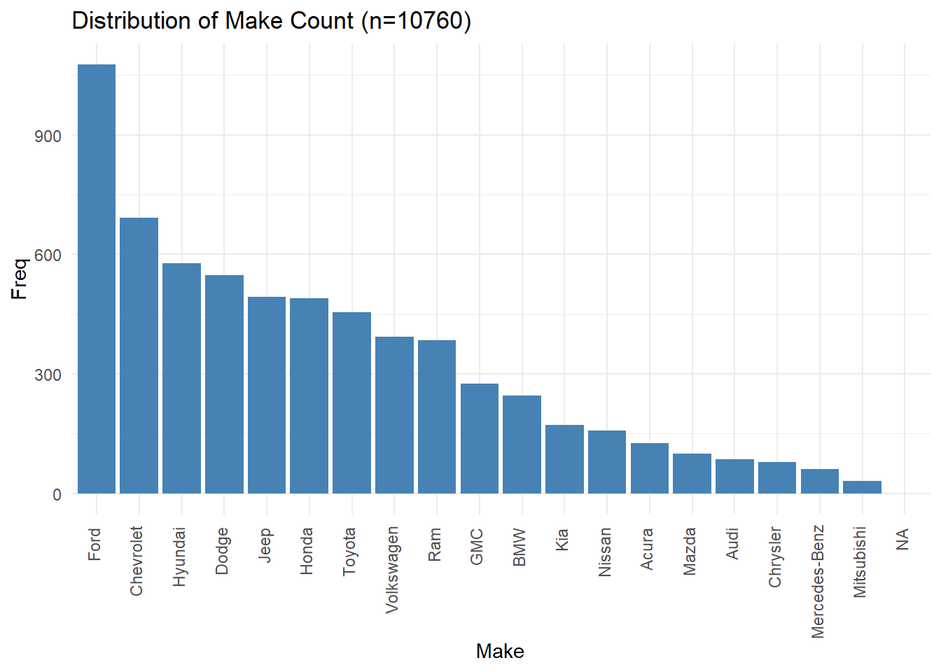

## Model (Categorical Independent Variable)

Manufacturers make a number of different vehicles and differentiate them as models. Tesla for example make electric cars and offer 4 different models: Model S, Model 3, Model X, and Model Y. This data is a string.

There are 576 different models.

## Kilometres (Continuous Independent Variable)

Kilometres is an integer value and refers to the number of kilometres the vehicle has been driven. In some cases the user might have entered miles instead of kilometres but there is no way for us to know if that is the case.

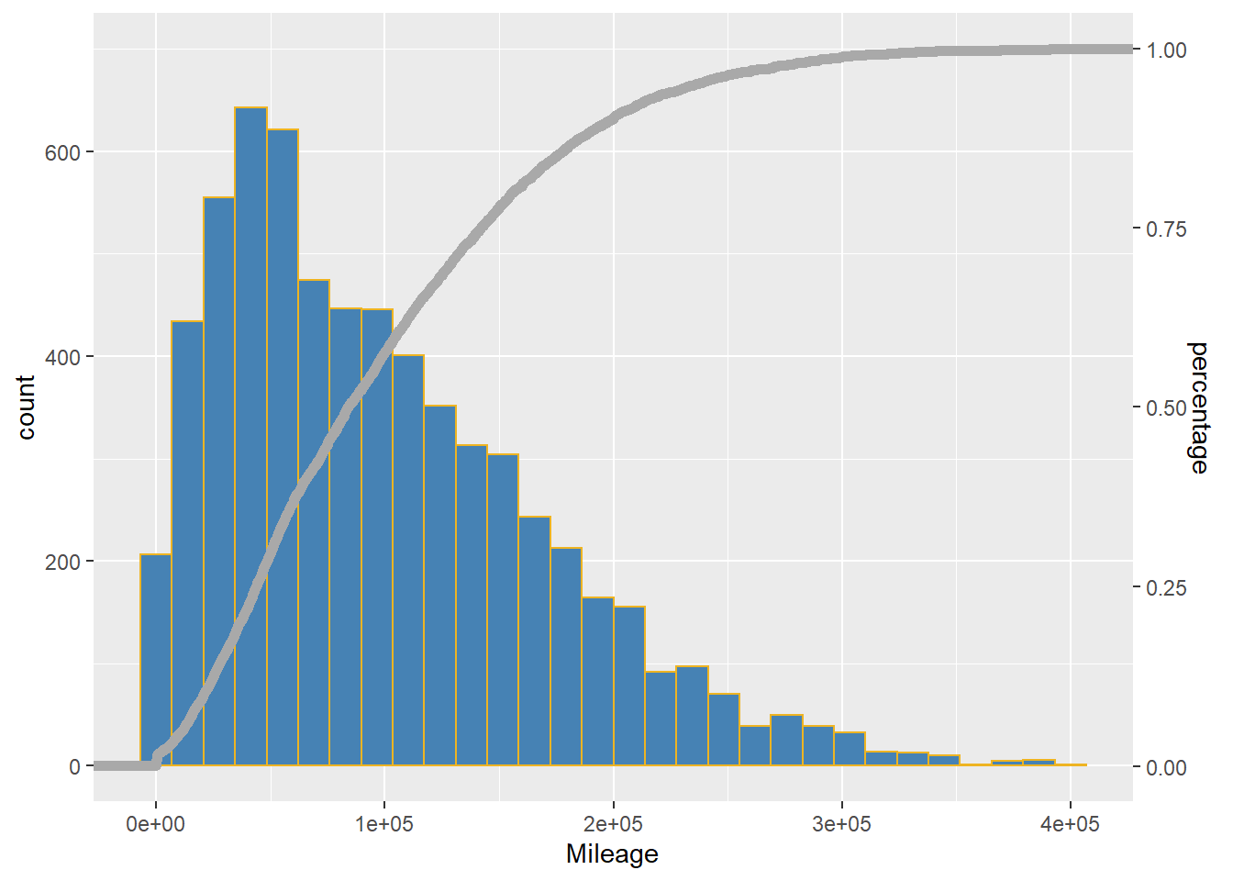

## Wheel config (Categorical Independent Variable)

Wheel config refers to the driveline configuration of a vehicle. The data does not consider motorcycles. All entries have at least 4 wheels. Vehicles can have the following drive system Front-wheel drive (FWD), All-wheel drive (AWD),na,4 x 4,Rear-wheel drive (RWD), and Other. AWD is not the same as 4x4. AWD means all wheels are driven at all times, whereas 4x4 means that the driver can select 2wd or 4wd.

The proportion of each driveline type are illustrated on the pipie chart below. Note that there are almost as many AWD vehicles as front wheel drives on Kijiji.

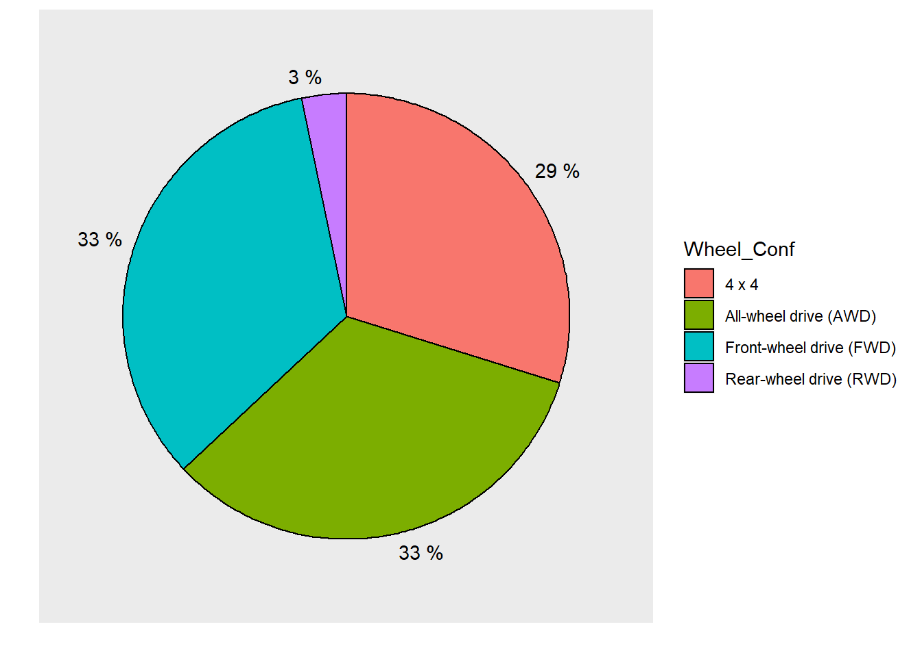

## Transmission (Categorical Independent Variable)

Transmission refers to how gears are selected in the vehicle. Either the vehicle is automatic, or the gears are selected manually. There are only two classifications for this predictor: Automatic, and Manual. There are very few manual transmissioned vehicles out there, approximately 3%.

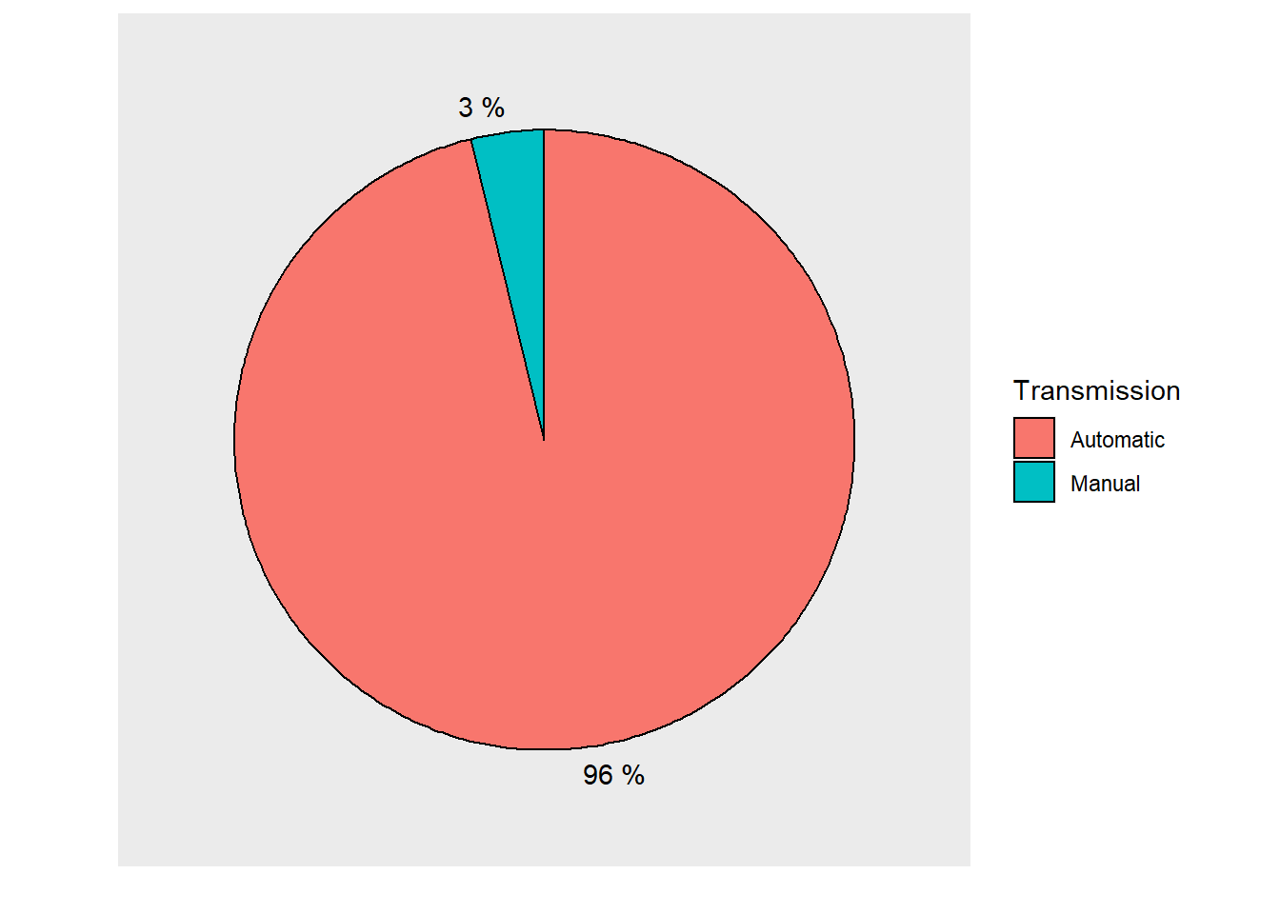

## Fuel (Categorical Independent variable)

This predictor refers to the energy source for the vehicle. There are four different categories: Gasoline, Diesel, Hybrid-Electric, and Electric. For the most part the vehicles on Kijiji are gasoline powered. Very few, ~1% of the vehicles are diesel powered, and even fewer are electric cars.

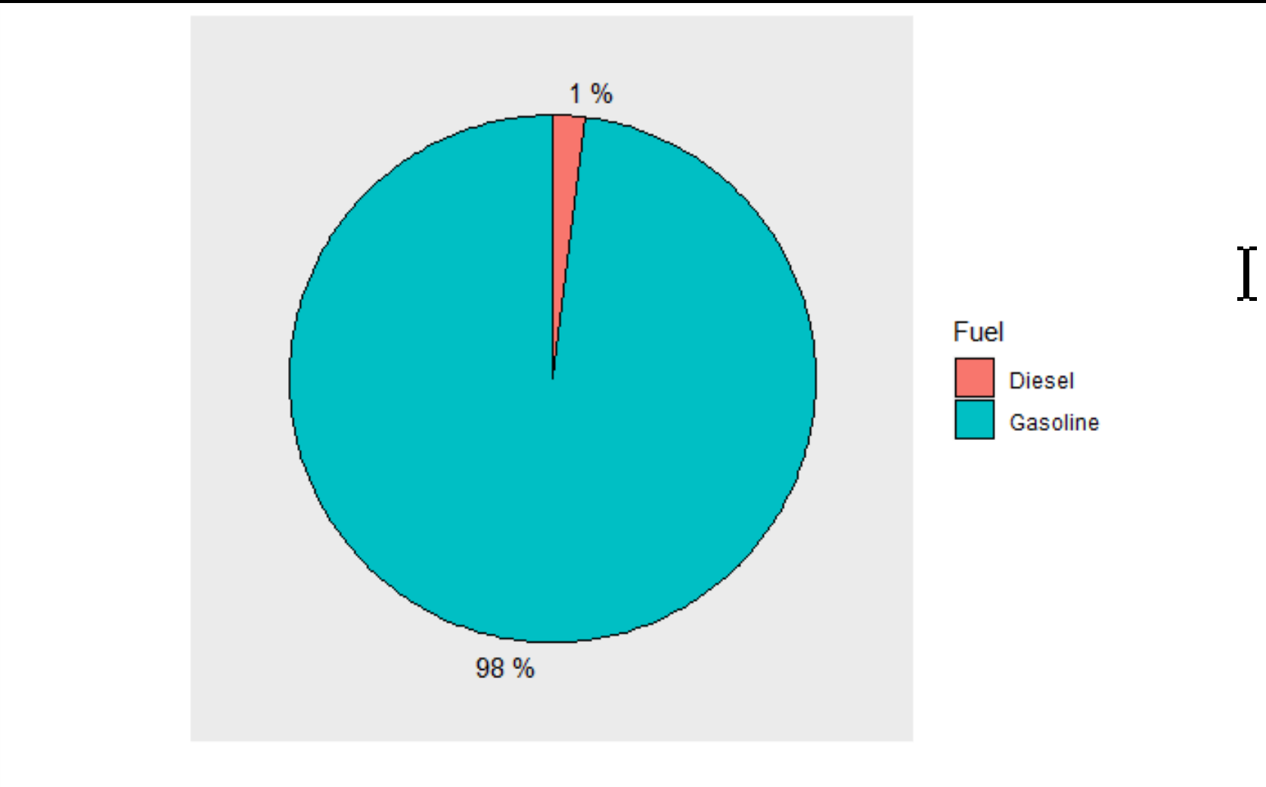

## City (Categorical independent Variable)

Data was collected for vehicles in the following cities: Calgary, Edmonton, Toronto, Vancouver, Winnipeg, Fredericton, Halifax, Regina, Whitehorse, and Charlottetown. The data was collected randomly. No effort was made to curate it.

## Price (Continuous Dependent Variable )

The most important variable in the study, and the target of the study, is price. Price was a difficult variable to manage becuase it is a data that was not controlled by Kijiji. Some users priced their cars strangely. There were brand new cars priced in the hundreds of dollars. There were cars that held real world values around $15,000 priced in the millions or at $-999. After a mechanical cleaning of outliers, we observed a mean car price of 22573.64 over all data points. The histogram of car prices shows a strongly right skewed distribution.

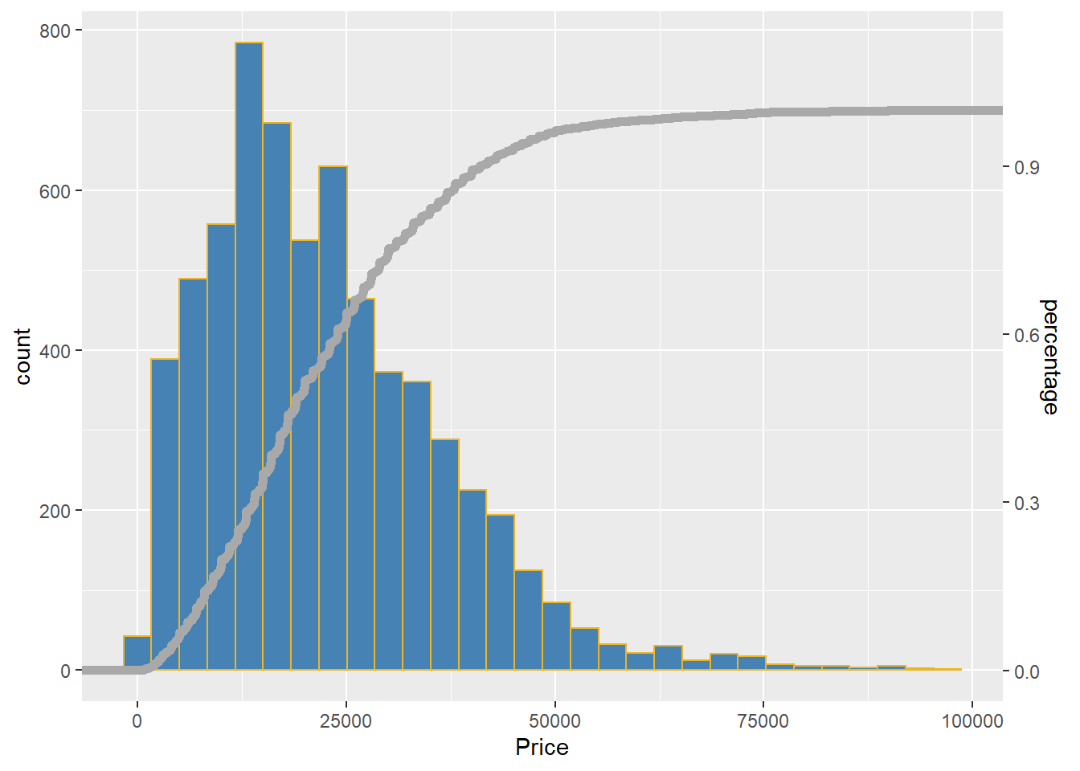

Some very interesting relationships fall out of an examination of the relationship between price and various categorical variables. Deep examination of these relationships falls outside the scope of this project so we will provide only a few observations.

There appears to be s spatial trend in car pricing where cars in Calgary, Edmonton, Regina, Vancouver, Whitehorse and Winnipeg are more expensive than the rest of the cities in the study. Convertibles and Pickups are by far the most expensive vehicles on Kijiji. Color plays a significant role in the pricing of a car, and as one would expect, Beige cars are priced lower than any other car. Lastly, 4x4s have the highest asking price followed by All Wheel Drive cars. IN Canada’s winter climate traction has a high price point.

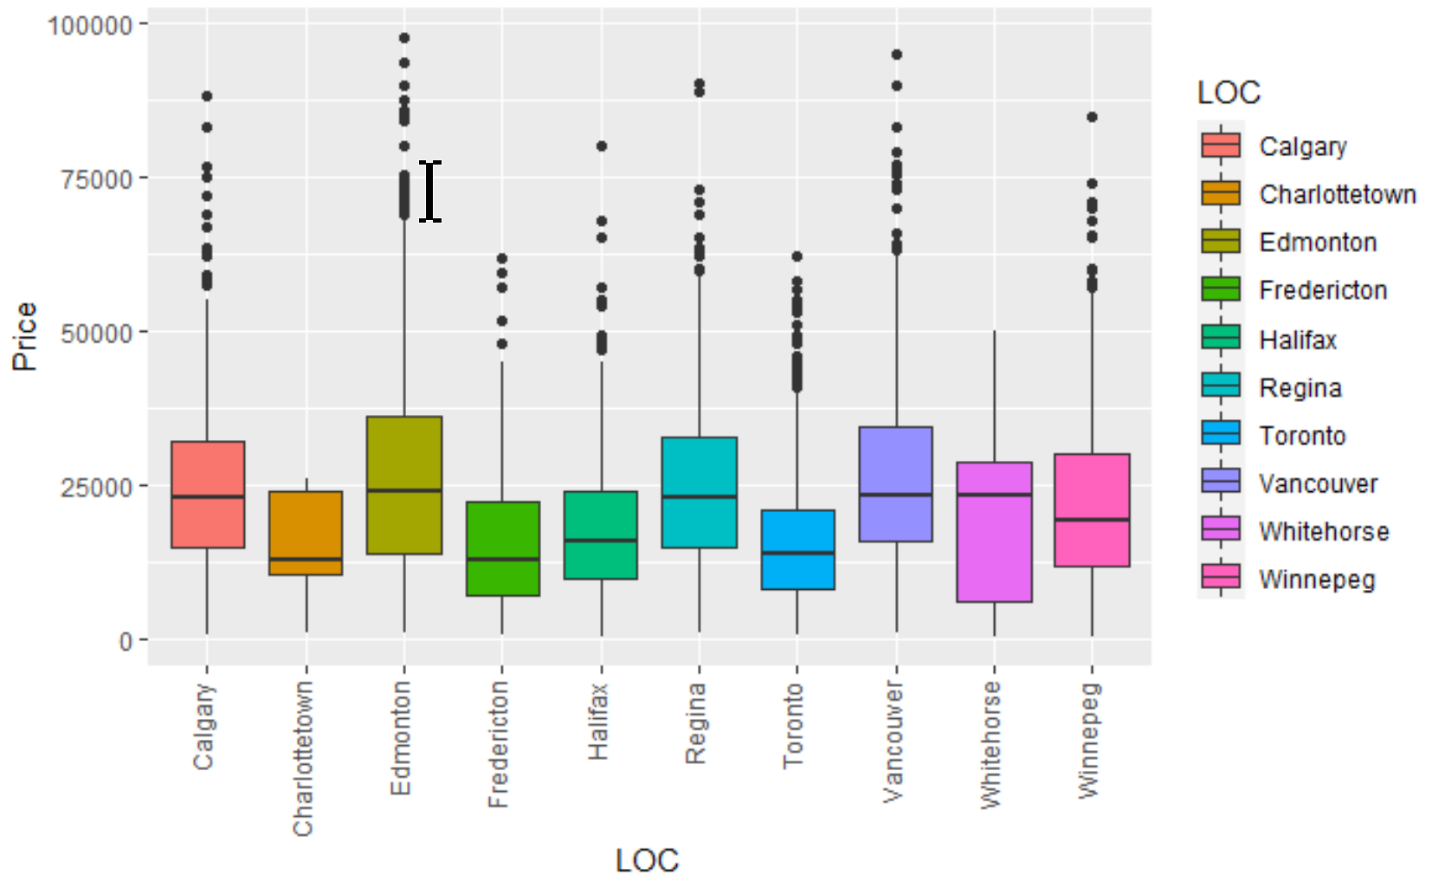

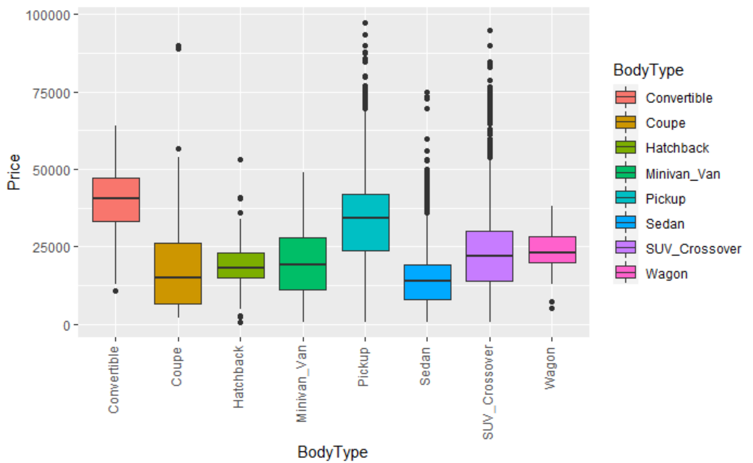

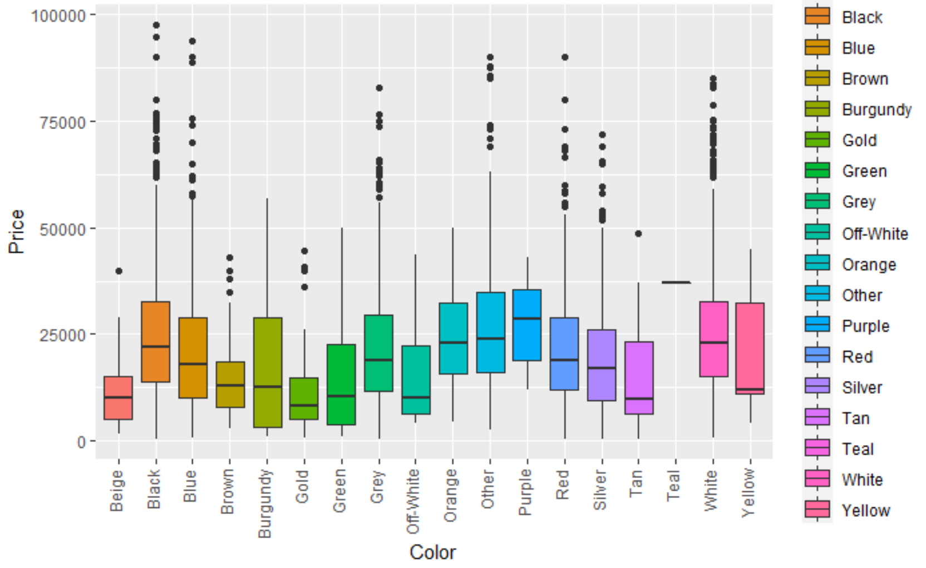

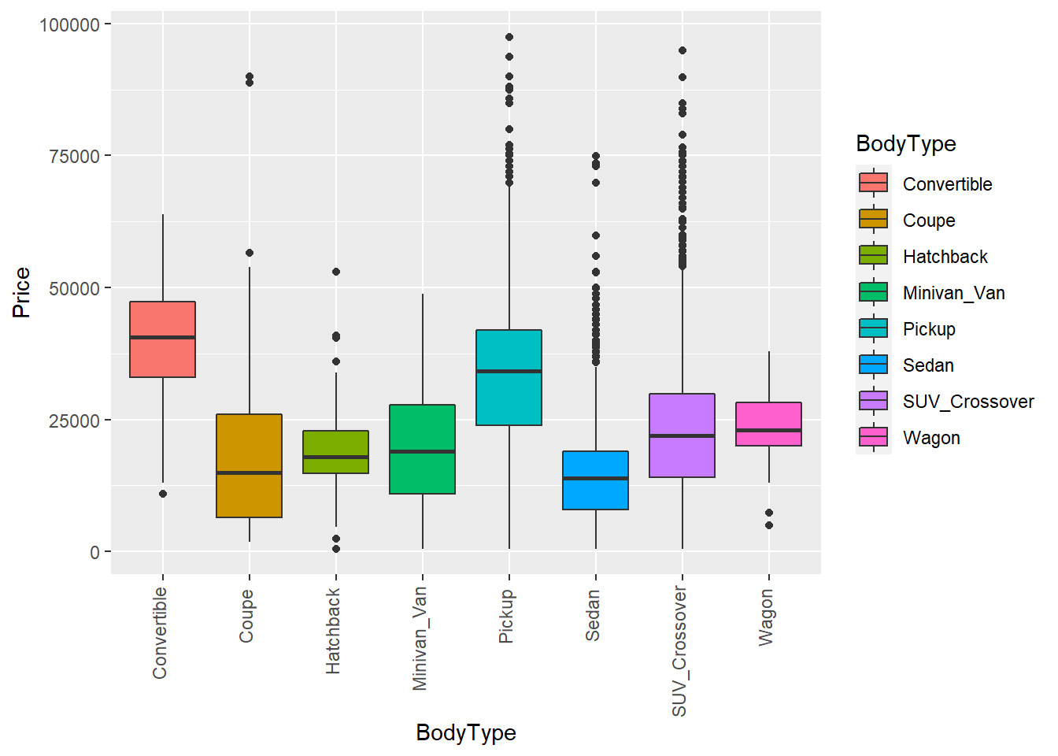

# Linear Modelling Strategy

Our planned modelling approach will be to first identify and manage known data problems like strong linear relationships among the predictors, or collinearities. We know the data has strong relationships between Make/Model/Price for pickups. This is because a few manufacturers make the same pickup but rebrand them under various manufacturer names. The public know this and some trucks have strong correlation in pricing. We will first attempt to acknowledge and illustrate the collinearity before moving on to multiple regression.

After addressing the intrinsic data issues, we will move on to a simple multiple regression model where we will identify predictor candidates for the next phase of modelling refinement where we consider interactions. In the simple multiple regression section of the report we will rely on tools like t-tests, f-tests, and ANOVA to select the best simple model.

Once in the refinement phase our modelling tactic will be to attempt to iteratively refine the model using the following loop:

1. Is the linearity assumption honoured?
2. Are the residuals normally distributed?
3. Are the residuals homoscedastic?
4. Do the residuals exhibit a trend with the year of observation?
5. Do we need to manage outliers?

The aforementioned tests will be relied upon to help us construct the best price prediction model we can. We will to reach this goal, we will add or remove predictor data as required.

## Known, but unavoidable linearities

There are known, but unavoidable collinearities within the data set. Collinearities can cause issues when calculating coefficients. The issue is generated when we take XTX to calculate the coefficients. When transposed, the values in the matrix can be inflated by correlations near 1, but variance can also be inflated when there aren’t enough predictor data. This is particularly the case when using categorical variables: certain combinations just dont have many, or any, data.

In our case the combinatorial generated by categorical data caused issues because cars are by their nature valued by the combination of options and models. Some manufactures like Dodge/Ram, and GMC/Chevrolet Chevrolet/Buick build and sell vehicles that are optioned identically and have similar market appeal and thus nearly the same price point. Consider the Chevrolet and GMC 1500 series pickups.

The distributions of Price for each truck is shown below. Note that they overlap each other nearly perfectly and have nearly the same mean. The scatterplot of prices on the two trucks are also shown below. By observation, there is strong correlation here. These relationships lead to collinearities that might reduce the confidence in the prediction ability of the model.

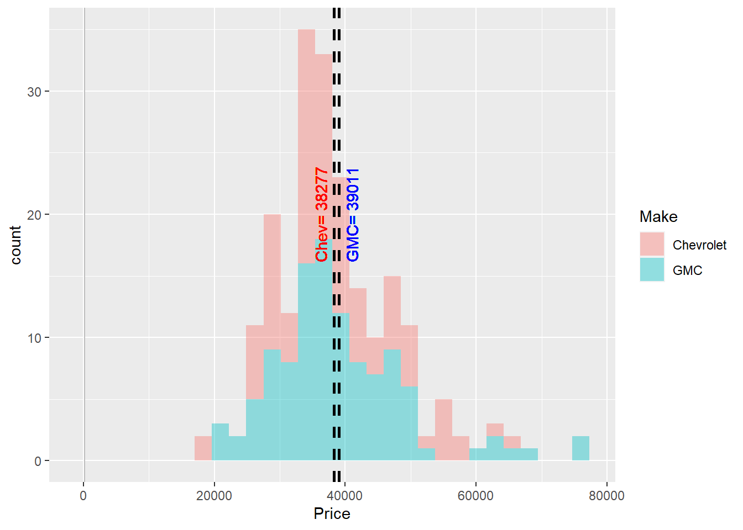

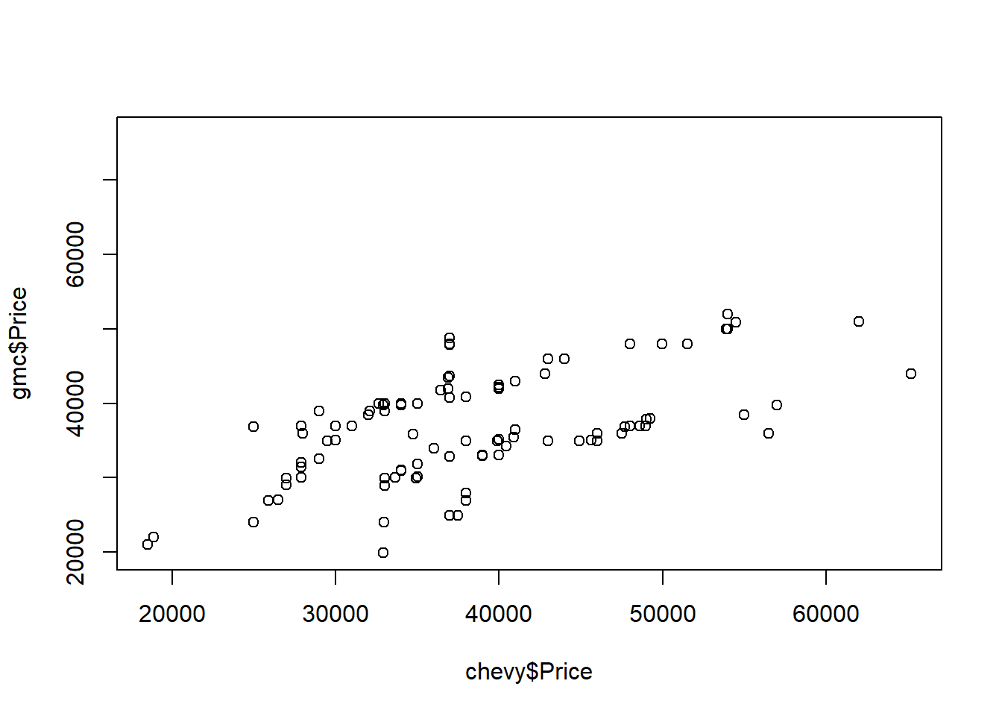

## Sensical Models versus Nonsensical Models

During the model exploration phase some predictors fell in and out of the model. We used variance inflation factor as a technique to select or reject a predictor, and some of the predictors inflated the variance to values that are thought to be high. In some modelling exercises these predictors would be rejected. In our case, VIF would have called for the rejection of some predictors that are essential to the utility of the model, namely Make and Model. Early in the modelling exercise we experienced VIFs in the order of hundreds and thousands. We chose to overlook VIF values for these predictors, because of the essential nature of Make and Model in predicting car price. Consider predicting the price of a sedan for example. It is generally well known that a 2020 Mercedes C Class will be priced higher than a 2020 Kia Rio. Were we to reject Make or Model from the model the model would be somewhat compromised. It is for this reason we overlooked VIF values when considering what we call essential predictors.

# First Order Model and Initial Coefficient Selection

Our first order model naively used all predictors to predict car price:

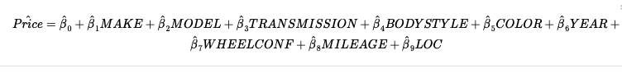

At this point we were interested to evaluate overall model utility , to check this we performed full model test

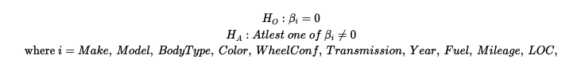

Anova Table

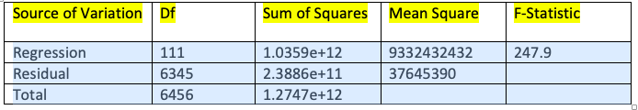

The Anova test gave a very small p value of < 2.2e-16, which suggested that the Price variable depends on at least one of the predictor variable

## Identifying Significant Predictors for Model

We built a first-order model which considered all of the original variables from the dataset namely: location (city), make (manufacturer), model, BodyType, Year, Mileage, Color, fuel, transmission (manual/automatic), and wheel configuration (2wd,4wd)

In our first attempt at running the full model with all the data, we were having performance issues with R-studio both on the university data science hub as well as running a local instance of the program. This was attributed to the large number of combinations categorical data of makes, models, city as well as the dataset itself which contained over 6500 lines of code.

For the purpose of VIF testing, we decided try working with a smaller subset of our data. A sample of 2000 cars were taken from the original data set to perform these tests. Once our final list of variables were selected, a VIF test was run using the entire dataset.

## Model 1:

In the first model, the VIF values for most makes and models were infinite. This was due to the fact that most make of a car are synonymous with one make. For example there is only one Focus model that is produced by Ford. It was decided to combine the Make and Model of each vehicle into a single name, MakeModel. We also decided that, based on relatively high p-values, color did not appear to be a significant contributor and was removed from the model.

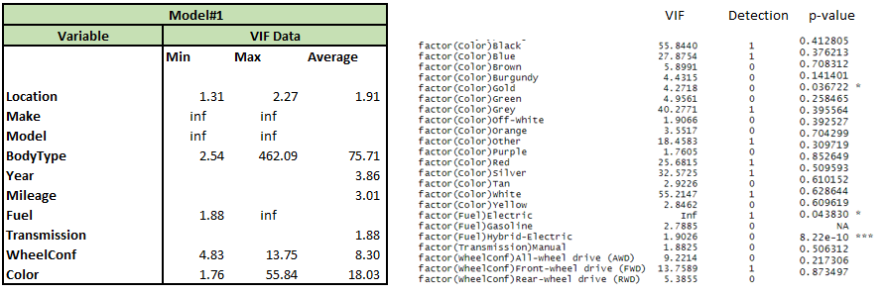

## Model 2:

The result of combining make and model resulted in a significant drop in VIF values; however, within the makemodel variable, the VIF values ranged from 2.5 to 460, which was a similar range of the variable BodyType, which had a range of 4.7 to 460. From this it was determined that BodyType had collinearity issues with makemodel. This was attributed to the fact that many makemodels had only one body type (for example the Ford F-150 is only available as a pickup). We decided to combine BodyType to makemodel to create a single variable make_model_bodytype. We also decided that we would drop Wheelconf as a variable due to its relatively high VIF and high p-values.

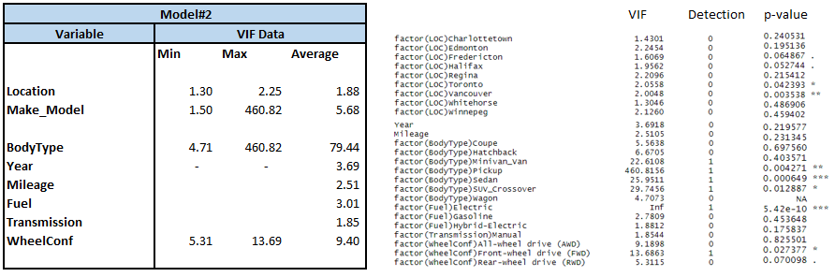

## Model 3:

The combined variable Make_ModeL_BodyType resulted in a significant drop in the VIF values from an average value of 79 to 3.3. At this point we decided to drop transmission as a variable due to the fact that its p-value of 0.35 indicated that it was not a significant contributor. As noted above, approximately 96% of the vehicles within the data set have automatic transmissions.

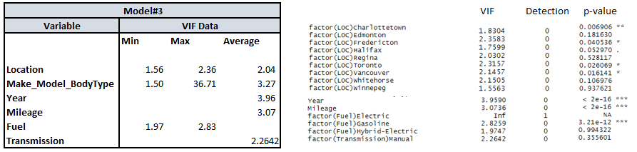

## Model 4:

This was our final first order model which was run on the sample of 2000 cars within our data set. Most of the variables show an acceptable value of VIF <5. The combined Make_Model_Bodytype variable had and average VIF value of 3.27 with a range of 1.50 to 36.71. Additional work could have been done to reduce the number of Make_Model_Bodytype entities by combining some BodyTypes. For example, the Volkswagon Jetta Sedan and Wagon could be considered as the same car. The VIF's for these two Bodytypes were 14.85 and 1.5 respectfully. Combining the two would have reduced the higher value to something more acceptable.

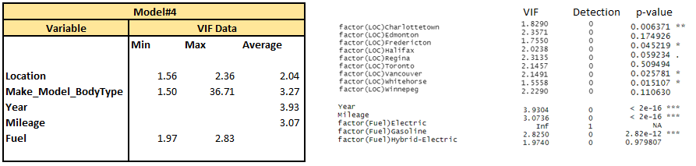

## Final First Order Model:

With less variables, it was now possible to run a VIF test for the remaining variables for the entire data set. Although there were some changes to the VIF values as compared to the smaller data set, we felt that we had successfully reduced the impact of multicollinearity on our model and would move to the next step of looking at variable interactions and higher order models.

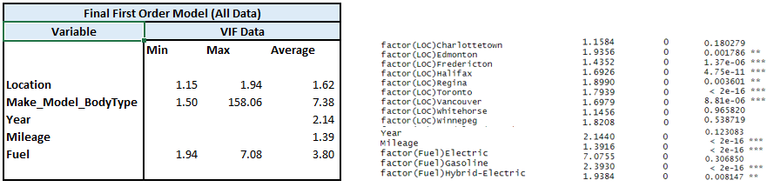

To summarize, based on the results of the VIF test and to reduce the VIFs as much as possible without compromising the model we combined the three :Make, Model & BodyType into one full name for each individual car and removed the Color, Transmission & Wheel Configuration to move forward



# Checking For Outliers

Next step was to check the Outliers in our dataset to offset any impact created by them on our model. We used Cooks distance approach and calculated our leverage point using the following function: hi > 3p/n, where hi is the leverage for the ith observation

p = the number of predictors

n= the number of the sample size

Following Graphs show the Outlier Check Result.

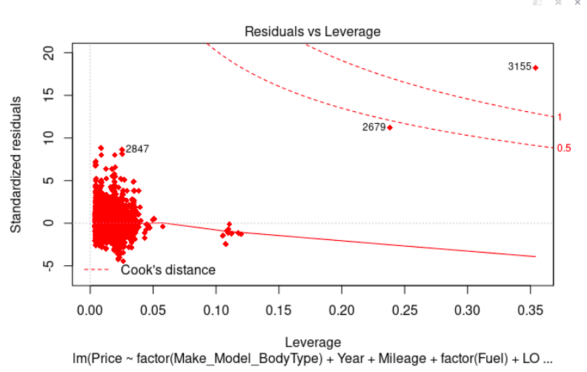

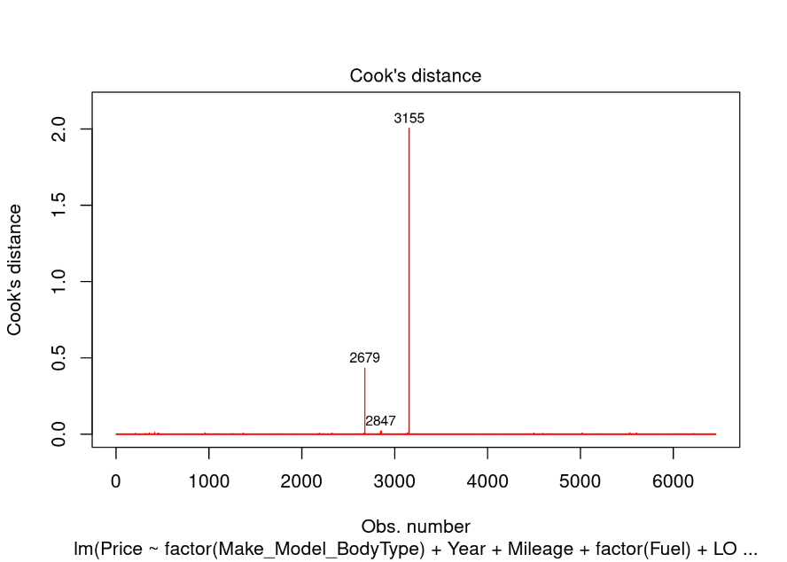

Based on our results and test we got a new clean dataset and we named it as “clean”. Moving forward Individual T-tests were used in our variable selection to determine the best predictors based on a significance level of α = 0.05

## T Tests for individual Coefficients

Hypothesis Statements for Coefficients:

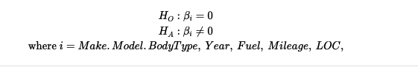

It is important to note here that Make_Model_BodyType, Fuel & Location are 3 categorical variables in our model which have many multiple levels, Here the idea is to find any one level for each categorical variable that is significant so that we can ensure that the entire categorical variable is significant for our model.

Main Effects T Test results : Here is a sample with one level chosen for the categorical variable that is significant, If none of the levels of a categorical variable is significant, then that categorical variable will be removed from the model

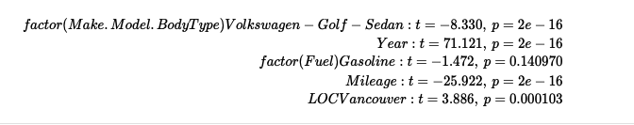

From the results of these tests, we would reject the null hypothesis in favour of the alternative. This suggests that Categorical variable Fuel is not significant. While the categorical variable Make_Model_BodyType & LOC has atleast one level that is significant and has p-value of less than α = 0.05. Our results have also shown that Year and Mileage are also significant for our mode. At this stage our main effects model is shown below:



## Checking for the Interaction Terms in our model

Individual T-tests to check for Interaction :

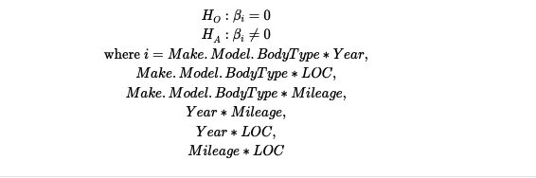

Here is how the complete interaction model looks like

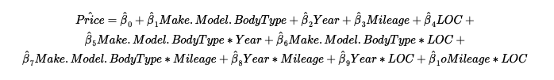

T-test results were used to find significant interaction terms.

Again, It is important to note here that Make_Model_BodyType & Location are 2 categorical variables in our model which have many multiple levels, The idea is to find siginficant interaction between any one level of these 2 categorical variables with the other variable so that we can ensure that our interaction term involving categorical variable is significant for our model. The results of the t-test for interaction term are:

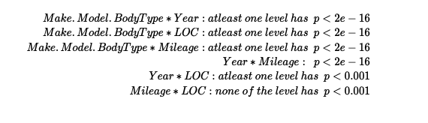

Based on the results of t-test the interaction between Mileage and Location came out not to be significant enough. Therefore our model with interaction term dropped the interaction between Mileage and Location variable and the model at this point was:

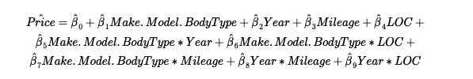

## Checking for Higher Order Terms (Higher Order Terms):

Since Year and Mileage are the only continuous variable therefore we will be checking whether any higher order term for these 2 continuous variable shall be included in our model or not.

To check this we plotted the ggpair graph first to check the trends.

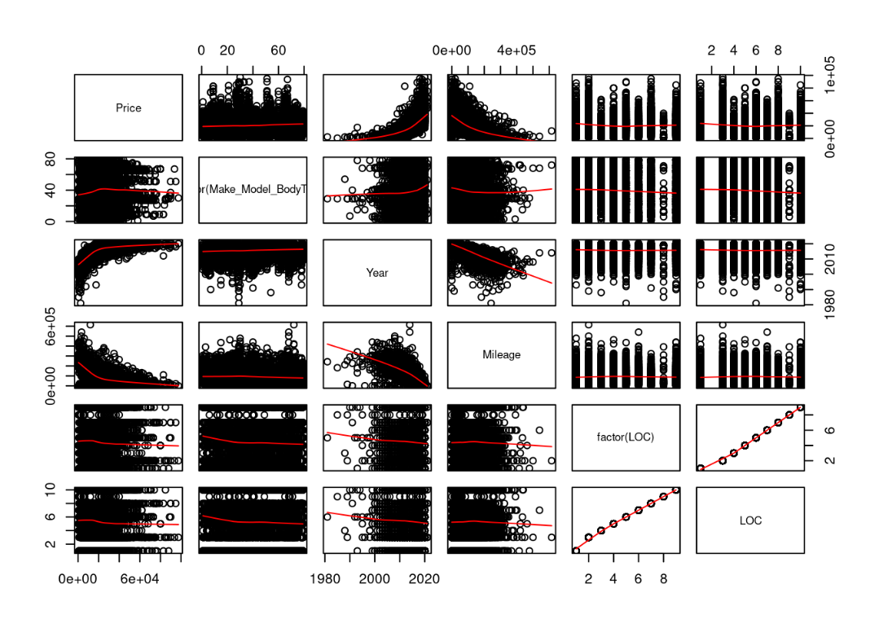

On the basis of this graph we see a curve for Year and Mileage therefore it made sense to check the higher order terms for both Year and Mileage. T-test result were used to find out the significant interaction term in the model. The results of the T-test for Year and mileage were:



On the basis of T-test, The higher order term for Year came out to be significant but the p value for square of Mileage was greater than α = 0.05. Moreover Including The higher order here resulted in Making the interaction between Year and Location insignificant. Further Parital F test was conducted to confirm this result. We didn’t go further to add more higher terms as adding an even higher term would have resulted in overfitting of our model

At this stage our model was as follow

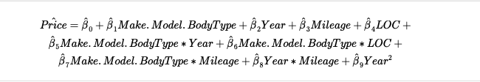

## Multiple Regression Assumptions

The sections below will address how we tested our model to meet various assumptions associated with running multiple regression. These assumptions must be tested, to ensure that our model results are, to an extent, trustworthy.

## Linearity Assumption

Our model relies on the assumptions that the true relationship between our predictors and response variables are linear in nature. Using residual plots, we checked to see if there are any discernible patterns that are non-linear.

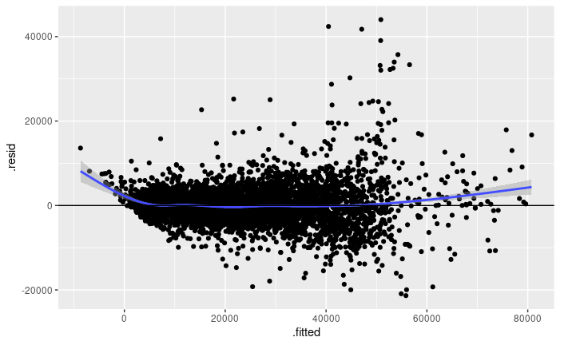

From the plot, we see that there is no prominent pattern shown and the model appears to form a flat line hence we concluded that our model seems to follow linearity assumption.

## Independence Assumption

There was No time series data involved in our dataset so there was no violation of the Independence Assumption. The Year variable in our dataset depicts the model year of the car and acts just like an attribute of the car without any time implication.

## Normality Assumption

In order for our multiple regression analysis be held valid, our residuals must be normally distributed. To test this, we can see that the distribution of the residuals in the histogram as well as the qqplot.

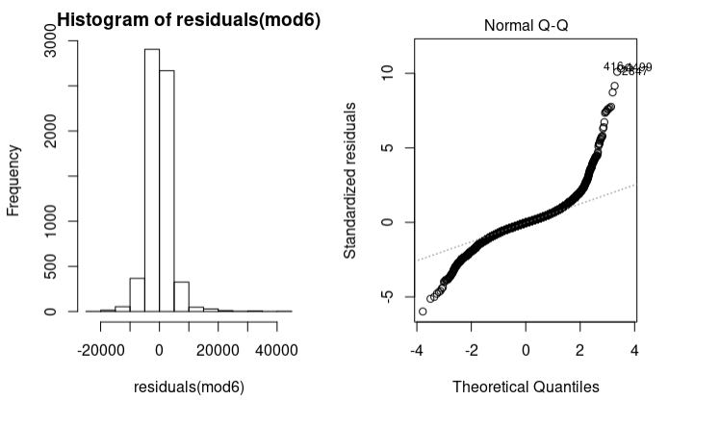

Histogram does not show a significant normal distribution . Additionally, a normal probability plot of residuals is provided. Again, we see that some of the data points approximate the normal line, however, there are a many points flaring outwards near the tails indicating the presence of possible outliers. We also used the Shapiro-Wilk test for normally distributed residuals:

H(0): The sample data is normally distributed

H(A): The sample data is not normally distributed

This suspicion is further confirmed in our Shapiro-Wilk normality test. Based on an α = 0.05, the Shapiro-Wilk normality test gave p value : 2.453998e-58. Hence we reject the null hypotheses and concluded that the residuals are not normally distributed

## Homoscedasticity Assumption

Next, we tested to see if our data is homoscedastic through a plot of fits to residuals as well as the studentized Breusch-Pagan test

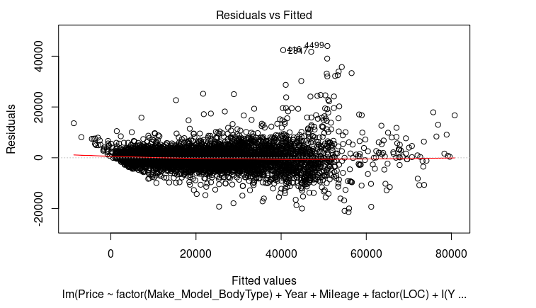

Looking at the plot of fits to residuals, we did not see any kind of wedge, or distributions of residuals that show a trend. Instead the graph displayed unequal scatter centred about a mean of 0. This is an indicator that the there is equal variance among the residuals. We used the Breusch-Pagan test to test that the residuals were homoscedastic:

H(0): Heteroscedasticity is not present

H(A): Heteroscedasticity is present

This suspicion is further confirmed in our the Breusch-Pagan test. Based on α = 0.05, The Breusch-Pagan test gave p value : < 2.2e-16. Hence we rejected the null hypotheses and concluded that The data in our model has Heteroscedasticity. Hence this assumption is not met.

To address the issue of the non-normal residuals we used a Box-Cox transform to transform the data. The plot below shows the maximum likelihood estimator based algorithm versus the lambda. The best lambda occurs at the charts peak of 3535354.

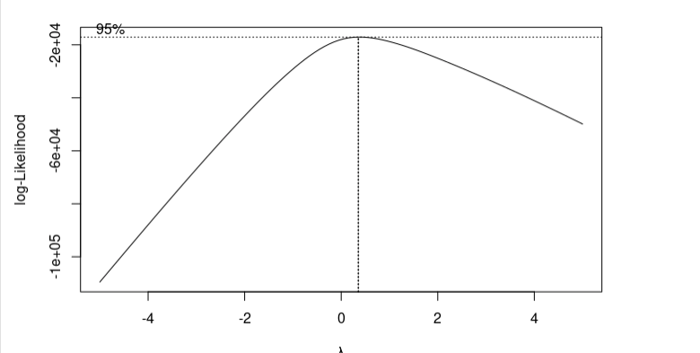

After applying this transformation to our to our data, refitting the model, and confirming that the status of the predictors had not changed we arrived at the following final model

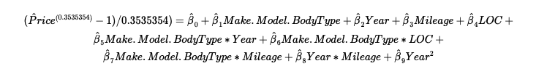

# Conclusion

To summarize our findings from the analysis, the main effects of Make_Model_BodyType, ,Year, Mileage, Fuel and Location are shown to be significant with less multicollinearity (VIF values) compared to the other predictor variables. We got significant interaction terms and rejected few with (p- values less than and not close to α = 0.05). Higher order term for continuous variable Year was included. Our Model appeared to be consistent with Linearity and Independence assumption. But, BoxCox transformation was used to transform our model and remove Heteroscedasticity and Normality. We managed to reduce the Heteroscedasticity and Non- Normality a bit but not completely.

Our final model after transformation was:



# The Effects of each individual independent variable:

β0 : The Y-intercept, this is the value you would predict for Y if all the predictors are zero. Since this will never be the case in our model therefore Here β0 has not meaningful interpretation

β1 : The coefficient of Make.Model.BodyType variable. This will give an average difference in the price at each level of categorical variable when rest all the variables are kept constant.

β2 : The coefficient of Year variable. Just whole number value reflecting the attribute of a car we consider while purchasing. This will give an average difference in the price of a used car model at change of 1 model year for the same car model when rest all the variables are kept constant.

β3 : The coefficient of Mileage variable. This is measured in miles. This will give an average difference in the price of a used car model for change of 1 mile for the same car model when rest all the variables are kept constant.

β4 : The coefficient of Location variable. Location is a categorical variable. This coefficient will give an average difference in the price of a used car model for change in a location for the same car model when rest all the variables are kept constant.

Our Rest of the coefficient values for all levels of categorical as well as continuous variable are attached in the appendix below.

## MLR

The model has adjusted R squared = 0.927. Which means that 92.7% of the variance in the response variable can be explained by our independent variables.

Also our model has a fairly low Root Mean Square Error equal to 6.014. RMSE can be interpreted as the standard deviation of the unexplained variance, and has the useful property of being in the same units as the response variable. Lower values of RMSE indicate better fit.

# Further Discussion

## Predictions of prices based on our model:

Two samples of cars were chosen to perform an analysis of our model.

The first sample was chosen to look at two groups of vehicles with step changes in one of the model variables at a time. The first vehicle was the BMW 5-Series Sedan. The first two rows are cars that are both 2011 models located in Calgary with different mileage. The third is the same car two but a 2018 model. The fourth car is the same as car 1 but is located in Vancouver. With the exception of car 3 (Year 2018), the model predicted very closely to the actual price.

A second grouping was chosen for a 2009 Ford F-150 pickup, which is a different bodytype (pickup vs sedan). Four different cities were chosen for this group with varying mileages. The model also gave reasonable predictions for these vehicles.



The second sample of vehicles were created by selecting 50 random vehicles with a relatively equal distribution of actual price range of the entire dataset. A table containing a list of the vehicles with their details, actual pricing, and predicted pricing are available in Table 1 (Second Sample of Vehicles for Prediction Testing) in the Appendix.

The following chart shows a graphical comparison of the actual posted price from the Kijiji data to the price that was predicted by our model. The graph shows a relatively good agreement between the actual and predicted vehicle prices (R2 = 0.9668 for the sample vs. R2 = 0.927 for the Model).

In general, we were relatively pleased with the accuracy of the predictions from the model.

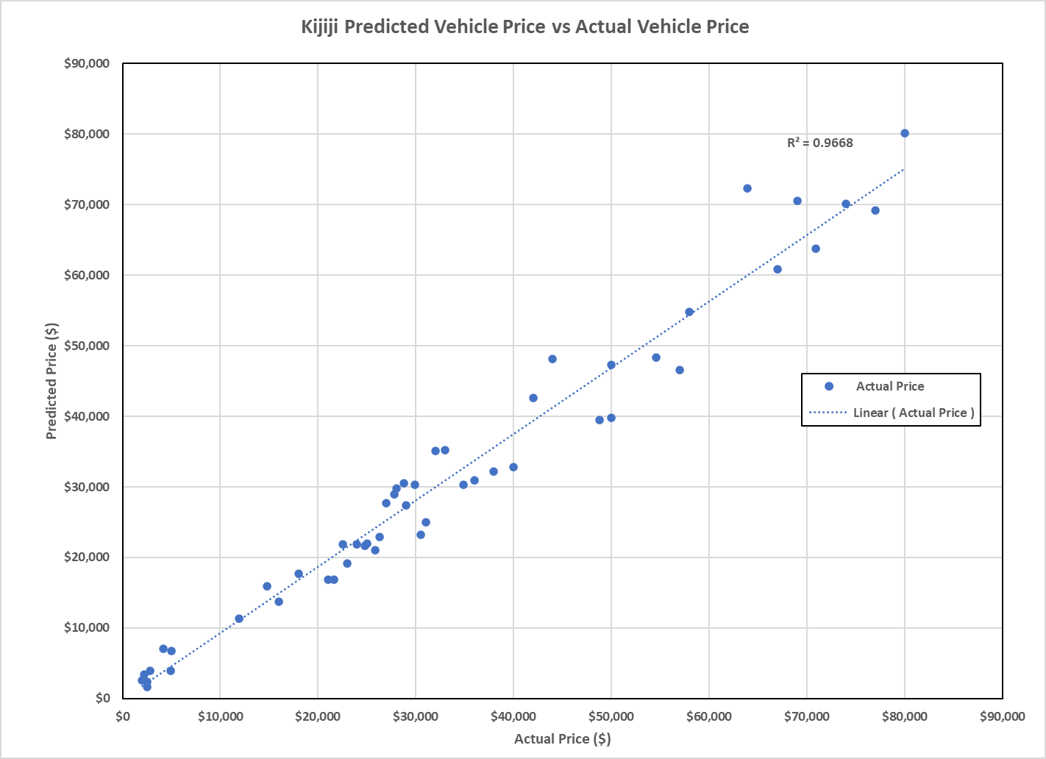

## Possible Improvements:

Given the level of multicollinearity in our dataset, more work could have been done to reduce the effects of multicollinearity on our model. We could have looked to reducing the number of Model_Make_BodyType entities. For example, the Volkswagon Jetta Sedan and Wagon could be considered as the same car.

After applying the transformation on our response variable, we were still not able to sufficiently meet the homoscedasticity assumption as well as the normality assumption. Perhaps more work or other possible techniques could have improved the model in these areas.

# References

<https://kijiji.com>

<https://www.nrcan.gc.ca/science-data/data-analysis/energy-data-analysis/energy-facts/energy-and-economy/20062#L4>

<https://www.ic.gc.ca/eic/site/auto-auto.nsf/eng/home>

# Appendix

We have two major categorical variables in our model. There were many levels in each of these categorical variables and the interaction terms associated with them. Following below is the list of our Beta values for each level of our categorical variables as well as for our continuous variables.

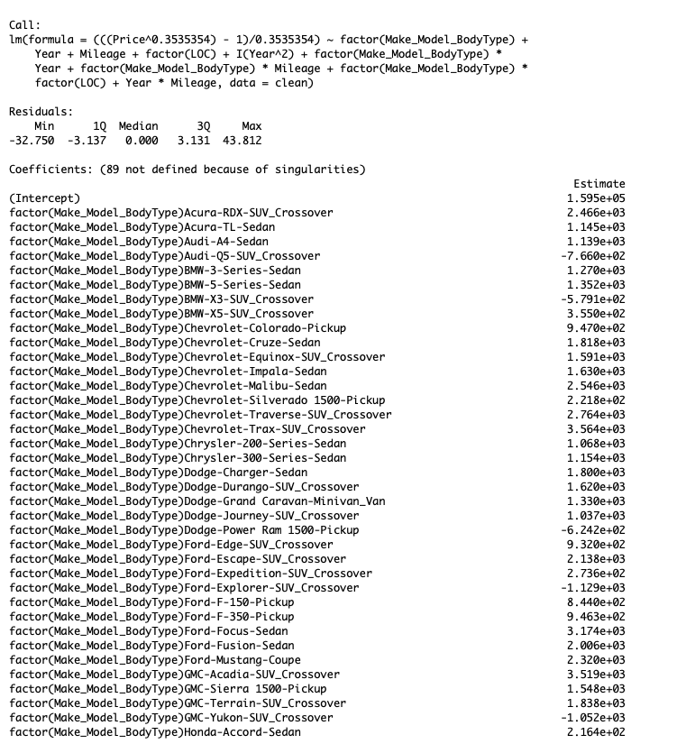

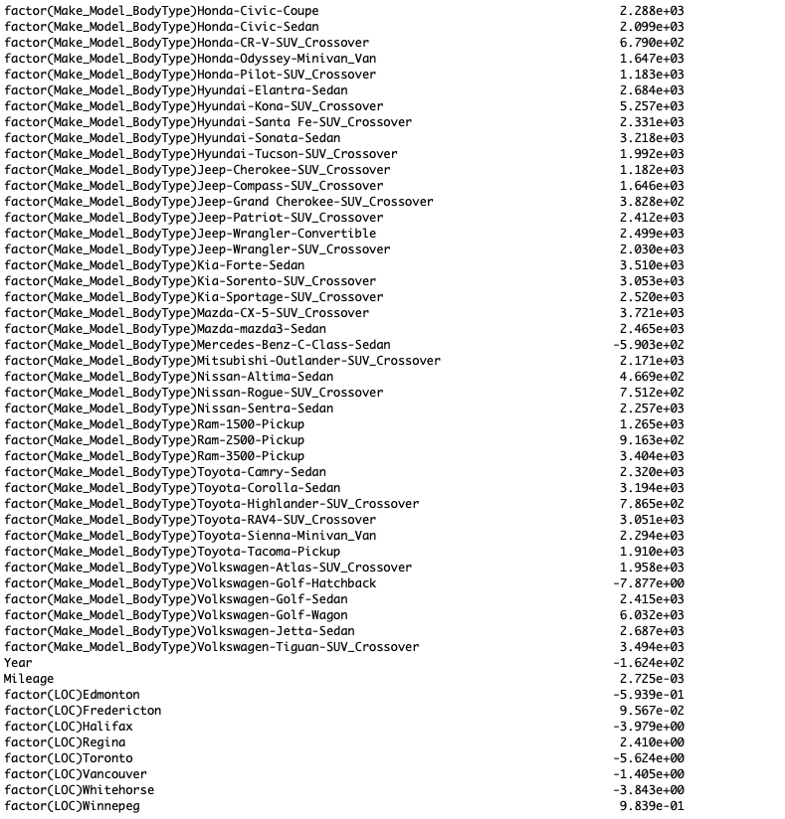

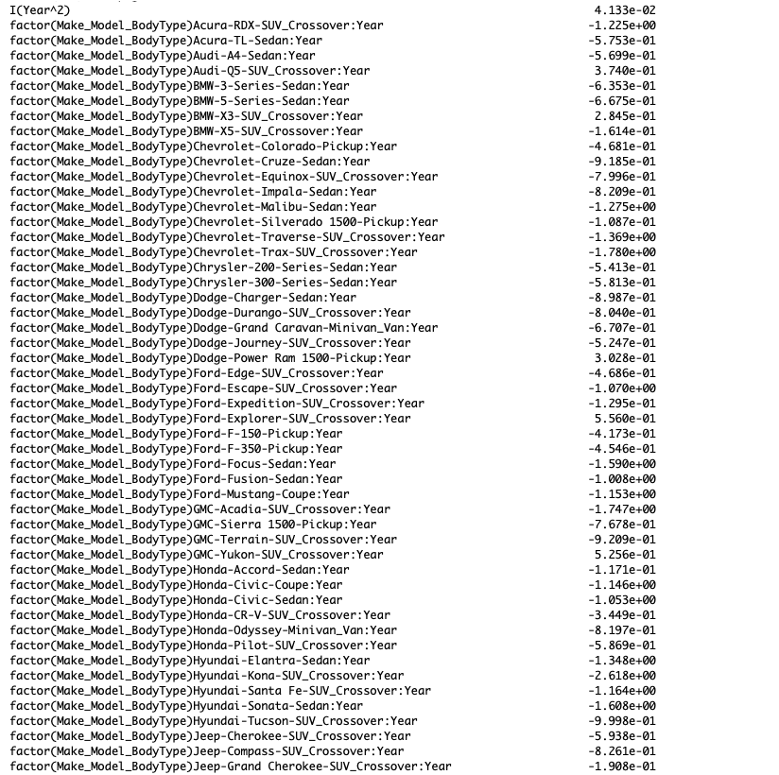

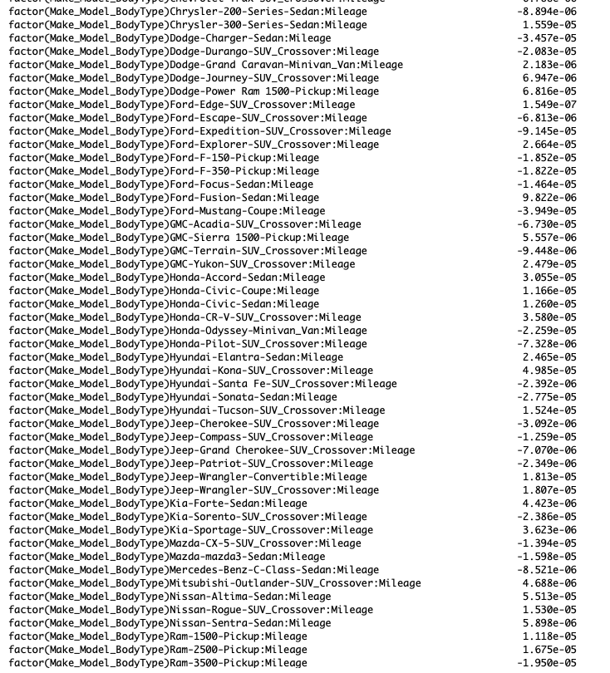

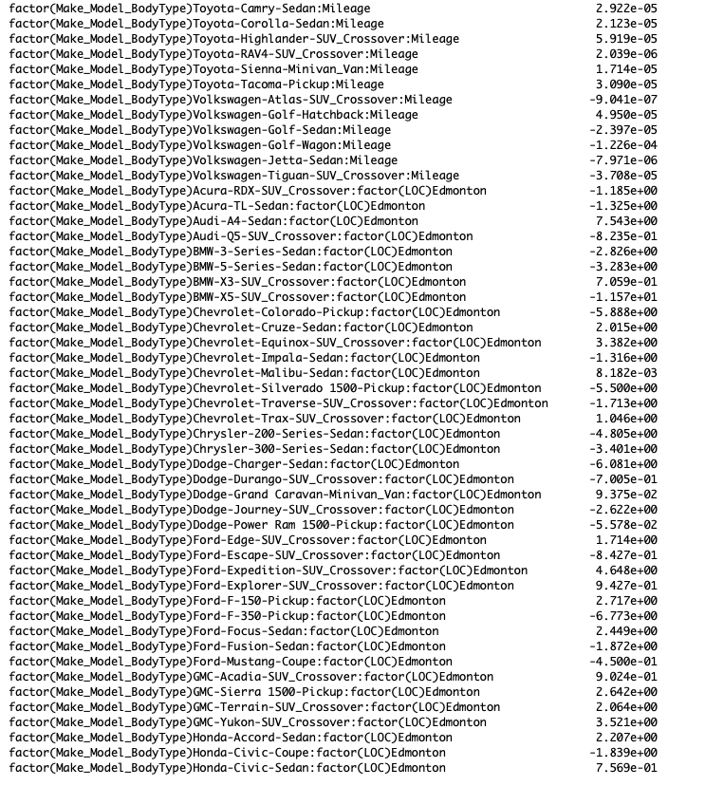

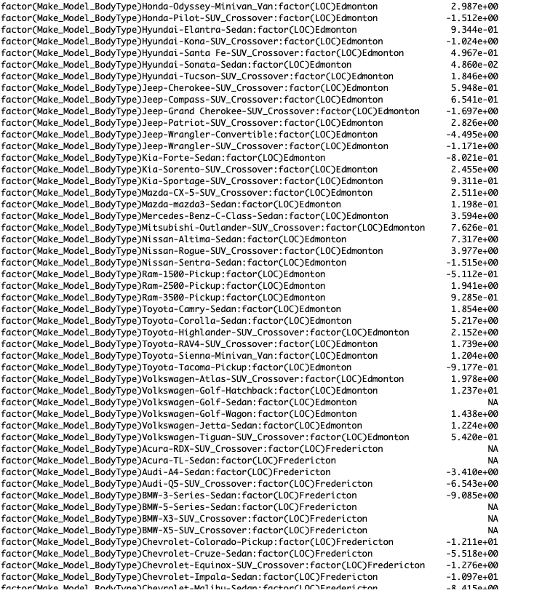

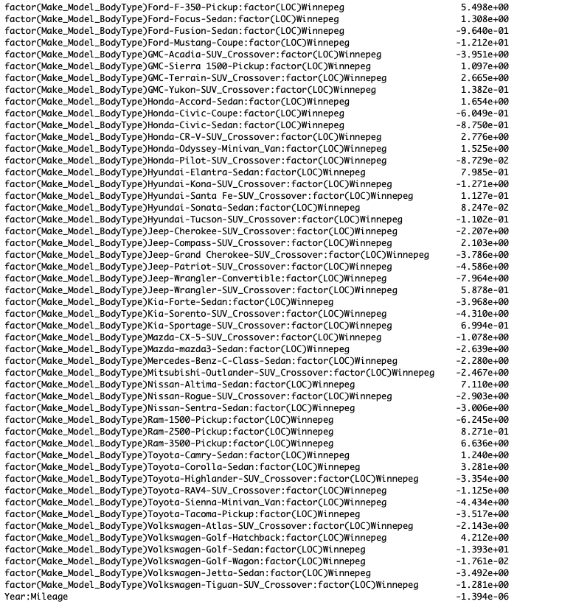

**Table 1: Second Sample of Vehicles for Prediction Testing**

